Russ Henderson
10th Magnitude
Azure Update Management
Automated Onboarding Guide – Log Analytics Method


- Create a shared Log Analytics Workspace, or use an existing one. The workspace must be in a region that supports mapping to an automation account. More details can be found at https://docs.microsoft.com/en-us/azure/automation/how-to/region-mappings. You can also select to create a workspace from the automation account during the deployment of the solution, but a default resource group will be created and a workspace with a random generated name will be created in the resource group.

- Create an Automation Account.

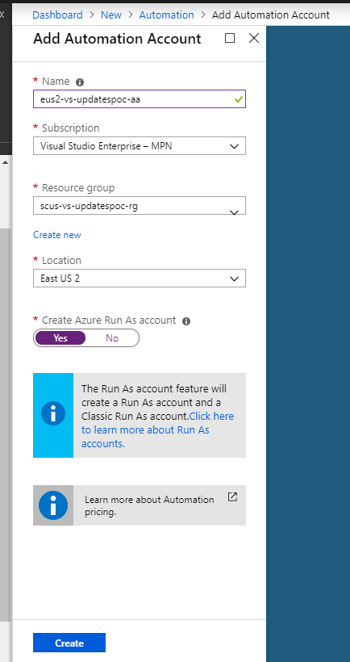

- Open the Automation Account and scroll down to the Update Management section and click Update management.
- Select the Log Analytics workspace that you created and click Enable.

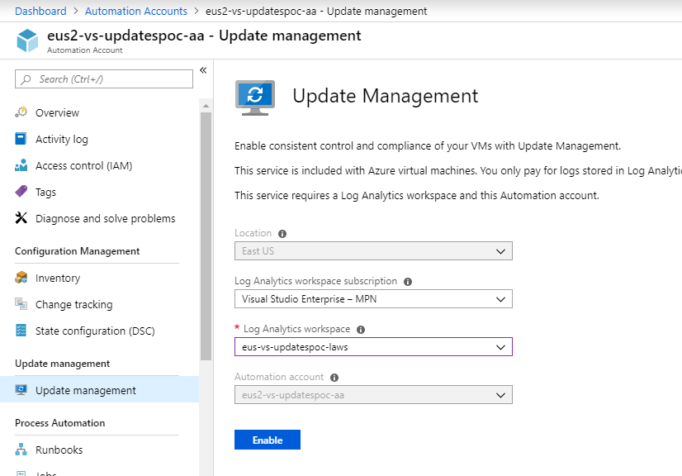

- The install of the Update Management Solution starts

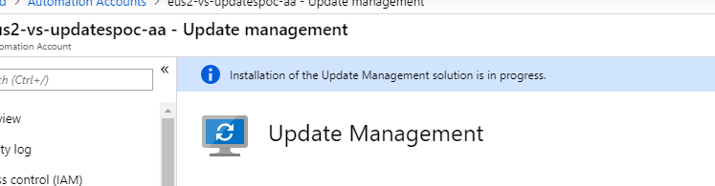

- When the solution setup is complete, click Manage Machines

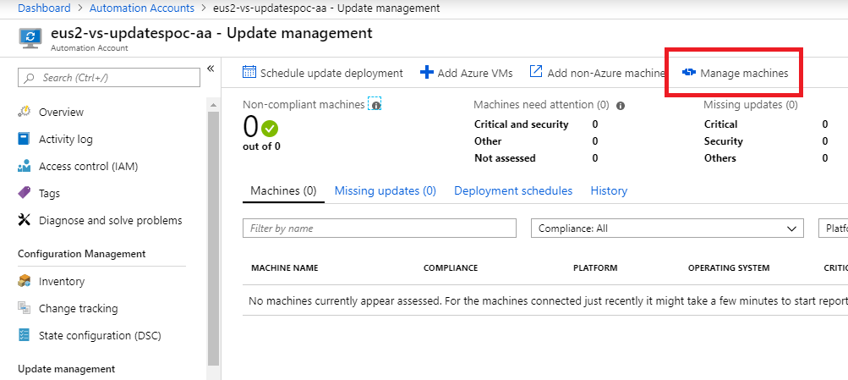

- Select Enable on all available and future machines and then click the Enable button.

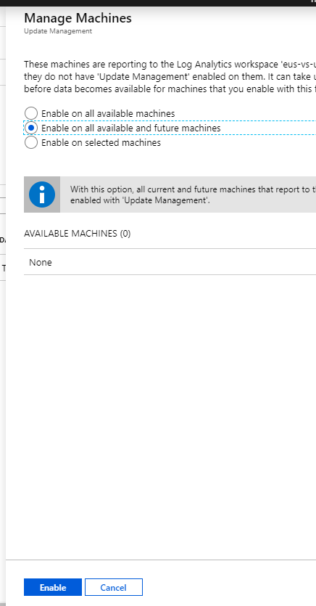

- After this option is set, the Manage Machines button will become greyed out.

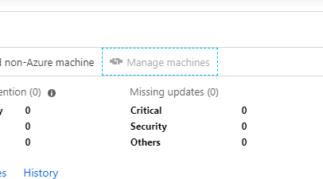

- For testing, I kicked off an ARM template to create a couple of Windows Server 2016 VMs with the Log Analytics Extension (formerly OMS) that points to the shared workspace.

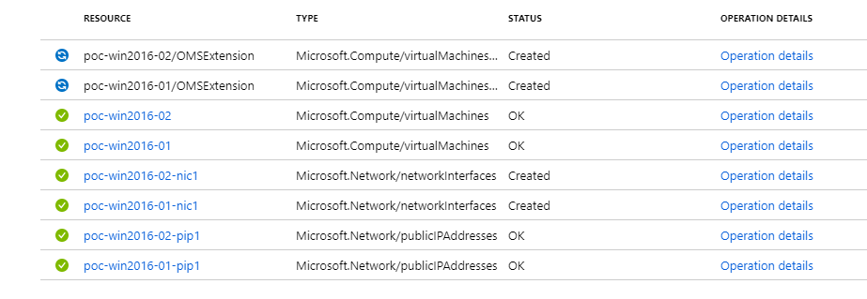
- The VMs register to the workspace when the extension is installed.

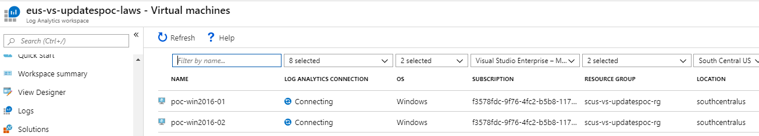

- After the VMs successfully register to the workspace, they are automatically onboarded into the Update Management solution.

